Spray Bark Collar Instruction
This Spray Bark Collar provides you with an effective and humane way to train your pets to stop barking faster and better. It’s safe with no side effects, no electric shock or hurt to your pets
Operation Instruction
Features:
1. It’s effective and safe with no side effects, no electric shock or hurt to your pets
2. Adjustable Collar for all size dogs
3. LED power indication：Flash red light when low battery
4. Fully charged in 2 hours and stand by for up to 10 days
5. 25-30 sprays per refill and 300-400 sprays per can
6. Small Size: 61 x 34 x 32.7 mm;
USB Cover
Microphone
Dog bark sensor. Pick up the dog’s bark.

Bark Spray Collar

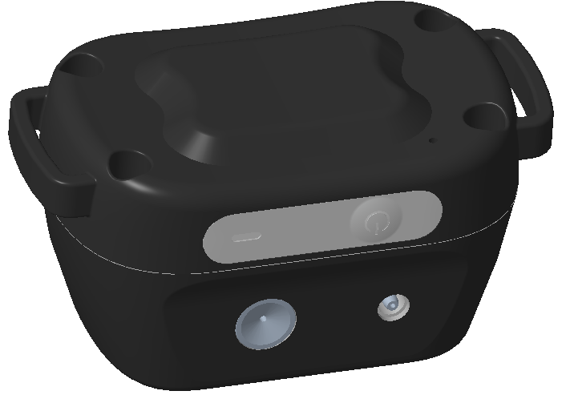
Refill Port
On/Off button
LED Light
Indicates the working status, low battery, charging status.

Spray Nozzle

LED light:
- When the collar is turned on, the LED light will flash green light every 5 seconds.
- LED low power indication. Red light will flash 1 time per second when battery level is low.
On/Off button:
- Press and hold on the button for 2 seconds, the collar is turned on after two short beep and Green LED light on.
- Press and hold on the button for 2 seconds, the collar is turned off after one long beep.
Refill Port : Refill spray
USB Cover: Charge battery
Microphone: Detect the barking
Spray Nozzle: Spray Ejects
NOTE: The LED red light flashes 1 time per second if the battery is low. Charge it promptly.
Test Spray Collar
Please test the spray collar according to following process:
Step1: Please press and hold on the “On/Off “ button to turn on the collar , the green led light will flash 1 time per 5 seconds
Step2: Insert the USB cable to charge the collar , the red led light will be on
Step3: Shouts to the collar’s microphone “WO,WO” ,The collar will spray
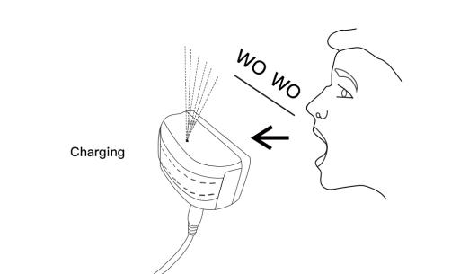

How to use
Special notes: The temperature of environment must be higher than 0℃ when charging. The ideal charging temperature is between 10-45℃.
1. Place the spray collar on your dog’s neck close to the ears.
2. The spray collar should fit snugly, yet loose enough to allow one finger to fit between the strap and the neck.
3. Make sure the Spray Nozzle is angled out and pointing towards the dog’s snout. For long-haired dogs , it may be necessary to trim the neck hairs along the spray path.
4. Ensure the Refill Port is clean . If any dirt or debris exists in the Refill Port , please clean the port before filling.
5. The device will eject spray automatically when detect the dog barking . The collar sprays only one time if the dog's barking is continuous without interval over 1 second.
6. The device is safety with no negative impact, no electric shock or hurt to your pets.
7. Refill the spray: Hold the refill can vertically and push the needle into the nozzle of the tank ,then depress firmly 10-15 seconds to ensure the liquid in the tank 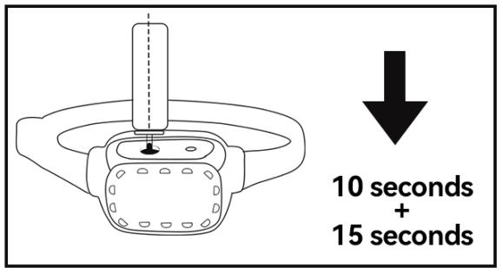

Caution
• If you do not use the spray bark collar for a long time , please turn off the collar to save power.
• Avoid leaving the collar on the dog for more than 12 hours per day.
• Make sure the spray nozzle is not blocked.
• Wash the dog’s neck area weekly with a damp cloth.
• Examine the neck area daily for signs of a rash or a sore in the first few days of use.
• If possible, reposition the collar on the pet’s neck every 1 to 2 hours.
• Check the fit to prevent excessive pressure.
• If a rash or sore is found, discontinue use of the collar until the skin has healed.
• If the condition persists beyond 48 hours, see your veterinarian.
Troubleshooting Guide
Problem#1: The collar sprays , but the dog keeps barking.
Check to make sure the Spray Nozzle points towards the dog’s snout .
Make sure your dog’s hair does not block the spray path . If so, please trim the hair so the spray can reach the snout area.
Problem#2: The LED light flashes Red light to indicate low power .
If the red LED flash quickly , the battery is low power , please charge it quickly .
Problem#3: The spray leaks out around Refill Port when you try to refill citronella spray.
Hold the spray can upright .If it is held at an angle, it will not create a good seal.
Press firmly on the spray can to create a good seal.
Problem#4: There’s no spray from the collar after several time sprays. It seems not work anymore.
Please notice that the collar is sold without spray or with only little testing spray inside. So you should refill the collar with spray before your first time use.

Safety Warning
• Do not use it as a toy for children.
• Do not use this product if your dog is aggressive.
• The Bark Control Collar is safe and effective for all breeds and sizes of dogs.
• Do not put it near to a furnace or a place with high temperature.
• Do not charge batteries in hot areas, keep far away from fire

