Remote Spray Trainer
Operation Guide
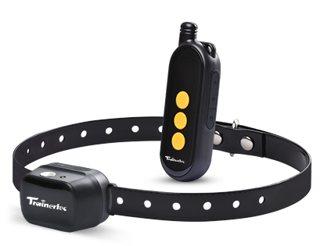

Remote Spray Trainer Operation Guide
Thank you for choosing SP32 Remote Spray Trainer. Our mission is to offer the best electronic training solutions. We want to ensure your dog’s safety by providing you with the tools and techniques to successfully train your pet. Please feel free to contact us if you have any problems and we will resolve them immediately.
Please read the complete operation guide carefully before starting to train your dog including the FAQ.
This instruction is suitable for Remote Spray Trainer SP32.
IMPORTANT SAFETY INFORMATION
Not for Aggressive Dogs. Do not use this product if your dog is aggressive, or if your dog is prone to aggressive behavior. Aggressive dogs can cause severe injury or even death to their owners and others. If you are unsure if this product is appropriate for your dog, please consult your veterinarian or certified trainer.

CAUTION Please read and follow the instructions in the manual. Proper fit of the collar under the dog’s neck is important. A collar worn for too long or made too tight on the pet’s neck may cause skin damage. Ranging from redness to pressure ulcers; this condition is commonly known as bed sores.
- Avoid leaving the collar on the dog for more than 8 hours out of every 24 hours and try to reposition the collar on your dog’s neck every 1 to 2 hours if possible.
- Check the fit of the collar to prevent excessive pressure..
- Examine the contact area daily for signs of a rash or a sore. Brushing the coat daily may help.
- If a rash or sore is found, discontinue use of the collar until the skin has healed.

Do not expose the device to freezing temperatures -32°F or
0°C or to conditions warmer than 113°F or 45°C. Do not leave the unit in direct sunlight. Never leave the unit in a car where the device can heat up to high temperatures 113°For 45°C.
AEROSOLS:
1.Keep out of reach of children.
2.Contents of the refill can and the spray collar are under pressure.
3. Use only in a well ventilated area. Use only as directed.
4. May explode if heated, do not heat. Do not expose to temperatures over 113°F or 45°C.
5. Do not burn. Do not dispose of in fire, even when empty.
6. Keep out of direct sunlight.
7.Do not leave the aerosol can in a vehicle where temperature could exceed 113°F or 45°C.
8.Store in a cool location.Keep away from sparks or flame.

Do not smoke while refilling.
9. Do not puncture. Contact of liquid propellant with skin may cause frostbite.
10. Do not ingest. In case of accident, seek medical care. If swallowed, call a poison control center immediately.
The Remote Spray Trainer is not a toy. Keep it away from the reach of children. Use it only for its pet training purpose.
These steps will help keep your pet safe and comfortable. Millions of pets are comfortable while they wear spray collar.
Training sessions which are shorter and more positive (10-15 minutes) are often the most effective.
Do not use the collar on a dog that is under 6 months old.
Improper or inappropriate use of a training collar system can be harmful. Please use this product correctly and pay attention when training your dog.

Table of Contents
Components…………………………………………....6
How the system works…………………………............6
Main Features………………………………………….7
Transmitter…………………………………………….9
Receive Collar………………………………………...11
Charging……………………………...……………….12
Match a Receive Collar………..………….…………...14
Training Guide……………………………………..…..15
General Training Tips.……………………………........16
How Dogs Learn……………………..……………..….18
Frequently Asked Questions…………………………...19
Troubleshooting Guide…………………………………21

Components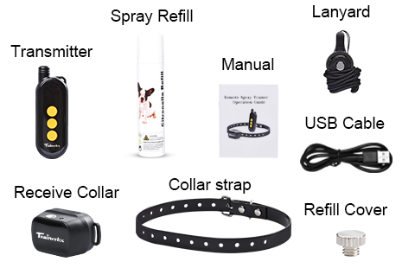
How the System Works
The SP32 Remote spray collar has been proven safe, comfortable, and effective for all pets over 6 months old. This system assists you in controlling your pet without a leash in a long distance range. At the push of a button, the remote transmitter sends a signal, activating the receive collar and emitting safe spray or warning beep or vibration . Using the remote trainer consistently and correctly, many misbehavior that your pet exhibits can be corrected or any basic obedience commands can be taught.
Important: The actual distance of remote trainer depends on the way you hold the remote transmitter, the range may vary. Hold the remote transmitter in a horizontal position away from your body to achieve optimum range. Terrain, weather, vegetation, vehicles, buildings, transmission from other radio devices, and other factors will affect the range of your remote trainer.
Main Features
- Range up to 500 feet in open field.
-Suitable for all dogs
-Simple, easy to use.
- Train one dog only.
- Long and Short spray.
- One vibration.
- One warning beep.
- Rechargeable 3.7V Li-ion battery for receiver and remote control
-Strong TPU Collar Strap.
- LED low power indication for receive collar. Red light will flash 1 time per second when battery level is low.
- Comes with warranty.

Transmitter
Up Button
Power Button
Down Button
Led Display
Spray Button
Vibration Button
Beep Button
USB Cover

Led Display: Display the 3 training mode: Spray ,Vibration and Warning Beep; Battery level and spray level
Spray button: Press 1 time - receive collar emit one spray .
Vibration button: Press 1 time - receive collar emit one vibration.
Beep button: Press 1 time - receive collar emit one warning beep.
USB Cover: To charge the Transmitter , Open USB cover , connect The transmitter and 5V DC power supply via Type-C USB cable
Up button: Adjust spray level to long spray , press button 1 time ,the LED display “H”
Down button: Adjust spray level to short spray , press button 1 time ,the LED display “L”.
Power button: Press and hold on 1 second to turn on the transmitter, The LED display is on ;Press and hold on 1 second again to turn off the transmitter, The LED display is off.

Receive Collar
USB Cover
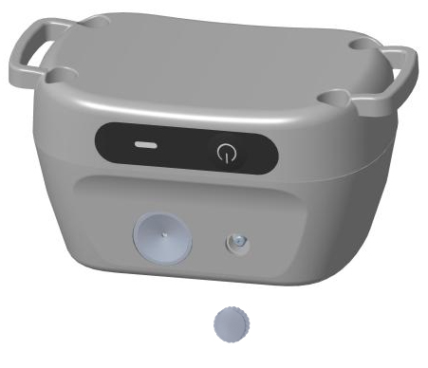
Refill Port
On/off Button
Spray Nozzle

On/Off Button:
Press and hold on 1 second to turn the collar on. Two confirming tones will sound and then the green LED light will flash 1 time per 5 seconds. Press and hold on 1 second to turn the collar off. One long tone will sound and the green LED light will stop flashing and turn off.
Refill Cover
Led Light

Function and Response Table
Function and Response Table
Function | LED Light Response
Unit is on | Green light flash 1 time per 5 seconds
Low battery | Red light flash 1 time per second
Charging | Red light is on
Full charge | Green light is on

Charging
The Receive collar and Transmitter can be charged rapidly in about 2 hours. Though 3-4hours is better for the battery life.
They can be charged by connecting USB cable and 5V DC power supply, such as cell phone adapter, notebook, or computer.
Special note: The temperature of environment must be higher than 0℃ when charging. The ideal charging temperature is between 10-45℃.
Do not charge battery in hot areas. keep far away from fire.
- Charge the receive collar
1) The red LED light is on when charging.
2)The green LED light is on and the red LED light is off when the receive collar is full charged.
3) The receiver’s red LED light will flash one time per second when the battery is low power. Please recharge the battery immediately.
2. Charge the Transmitter
1) The battery level is changing when charging.
2) The battery level is no changing when the transmitter is full charged

Match a Receive Collar
Step 1: Press and hold “ON/OFF” button. After two “beep” sounds, release the button, the power of receiver is on.
Step 2: Take out the transmitter. Press and hold on the button + button at the same time ,The Led display is “ P ” . Close to the receive collar 10-20CM , until hearing 5 “beep” sounds from the receiver then release .
Note: You should match receive collar within 30 seconds after
turning on the receive collar . Otherwise you have to
turn off receive collar then turn it on again to match .

TRAINING GUIDE
Fitting Collar on the Dog
Make sure your dog is standing then place the collar strap on the middle of the dog’s neck. The receiver should be on the underside of his/her neck, with the Spray Nozzle towards the dog’s nose.
The Receive Collar should fit snugly, yet loose enough to allow one finger to fit under the strap.
Ensure a Proper Spray Pattern
For the Receive Collar to perform properly, the nozzle must be positioned correctly and there must be a clear path from the Spray Nozzle to your dog’s snout.
1.Make sure the Spray Nozzle is angled out and pointing up towards the dog's snout.
2. For long-haired dogs, it may be necessary to trim the neck
hairs along the path of the spray. It is important that the spray reach the dog’s snout to be effective.
3.Turn off the collar , then refill the citronella spray. For optimal performance, the Receive Collar should be refilled before each use.
General Training Tips
1. Make training sessions short and positive (each session between 10-15 minutes.)
2. Train one dog at a time.
3. During the first initial training session, keep the dog in a familiar outdoor environment.
4. Use a long leash fastened to a non-metallic collar to help the dog's learning.
5. Be consistent. Give your dog a tone and/or spray with each misbehavior.
6. Teach the dog a command first before reinforcing the command with the remote transmitter.
7. Issue one obedience command at a time. Do not use the training system for commands that the dog has not learnt.
8. Do not over correct your dog. Use as few spray as possible to train your dog.
9. During training, look for all the positive changes in the dog's behavior and remember to reinforce them promptly with ample praise and reward.
10. If you notice one situation in which your dog misbehaves repeatedly, set up this situation as a training session. This will dramatically increase your chances of success.
11. If your dog has a timid reaction to the tone or spray (especially the first couple of times), do not be alarmed. Redirect his attention to a simple and appropriate behaviour (i.e. a known command such as “sit”).
12. Please keep in mind, that you should keep training
sessions short and end every session on a high note. Stop training and play with the dog as soon as the dog has accomplished a new level of proficiency.
13. Never use the SP32 Remote Spray Trainer to correct or eliminate any form of aggressive behaviour. If your dog exhibits such behaviour, contact a professional trainer. Aggression in dogs is the result of many factors - it may be a learned behaviour or it may be brought on as a result of fear. Another factor contributing to aggression in dogs is social dominance. Every dog is different.
HOW DOGS LEARN
Here are some basic guidelines that cover all your remote trainer work on obedience commands.
Follow a step-by-step introduction process on each command. Don’t assume that your dog will understand a remote trainer correction in connection with a command. The stimulus can confuse them initially, even if they knows the command.
Don’t introduce remote training around distractions.
Keep things simple for your dog in their first sessions. They can’t learn well when there’s too much distractions going on.
Frequently Asked Questions
Is the spray safe for my dog? Though the spray is unpleasant, it is harmless to your dog.
Is the collar waterproof?NO,Don’t immerse in water .
How old should my dog be before I use this device? It is recommended that your dog be 6 months old to use a training collar. Your dog should have learned the basic commands such as “sit” or “stay”.
The collar is too long, is it ok to cut off the excess collar?
Yes.
Can I use it on my aggressive dog? We do not recommend any of our products to be used on aggressive dogs. In this situation please contact your local veterinarian or professional trainer to determine if your dog might be aggressive.
Will I get exactly the 500 feet range as advertised? Testing for the 500 feet range is performed in perfect conditions. The range you get will vary according to terrain, weather, vegetation, as well as, transmission from other radio devices. For best results, make sure the collar has the light closest to the dogs nose and you hold the remote horizontally and away from your body.
Does the spray need to hit my dog’s nose ?
No. The spray is very fine and simply creates a mist in the region of the snout.
When will I know to refill the spray? We suggest that full refill the spray before use every time.
If don’t use it for long time,please empty the spray
Can I refill spray while the dog wears the receive collar ? No . Please take off it from your pet , turn off the receive collar , then refill the spray .
Troubleshooting Guide
Problem#1: No spray or beep when buttons on transmitter are pressed.
The receiver has not been activated. The receiver must be turned on otherwise it won’t work at all.
The receiver has not been matched to your transmitter. Follow the instructions to match.
Problem#2: The receiver light changes color to indicate low battery very quickly.
The unit has been left turned on in between training session. Make sure the receiver is turned off after use.
You are training in very cold weather.
Problem#3: The remote trainer doesn’t have range or the range is significantly reduced.
Either you or the dog is shielded by metal structures. Operate it far away from these structures.
The receiver is on backwards. For best range, position the receiver so that the light face toward the dog’s nose.
Radio interference. Wait a short while then try again, or move to another area.
Problem#4: The receiver can’t receive any signal or cannot work at all.
Check the receiver on/off button, make sure the receiver is turned on.
Check the transmitter, if it has a low battery, charge it first.
The charger is broken, please try in your computer.
Re-match the receive collar with the transmitter.
